C SEED Supermarine - The first real Superyacht TV and Speakers

Now available worldwide

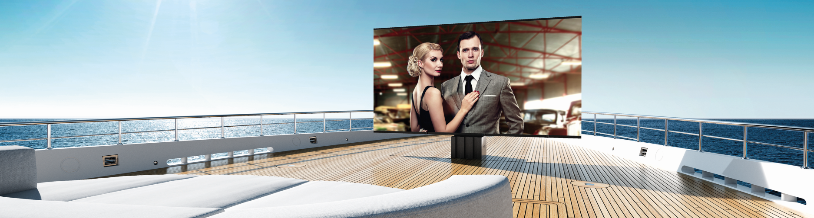

**Excellent news for the happy owners of the Superyacht: C SEED proudly announces the official release of the fully retractable Supermarine 201 / 144 TV and Supermarine Speakers for the ultimate yacht entertainment experience.**

Vienna/Los Angeles, March 2018.

Soon after winning the prestigious Red Dot design award for the world´s largest outdoor LED TV, C SEED received requests from the superyacht industry and set out to take this groundbreaking design to sea. Now the C SEED SUPERMARINE enters the market with the same uncompromising technical and visual sophistication that has earned the outdoor C SEED 201 TV by Porsche Design Studio iconic status.

**C SEED Supermarine 201 and 144 TV**

The single most spectacular engineering achievement of the C SEED Supermarine TV is its unique hydraulic drive system: A wildly sophisticated combination of vertical and horizontal drives retracts the whole huge 201/144 inch screen into a shallow compartment of only 78cm (31 inch) depth, saving valuable space on and below decks. Still, the C SEED Supermarine TV takes only 15 seconds to rise to its impressive height of 3m (9.8 ft.) with effortless ease.

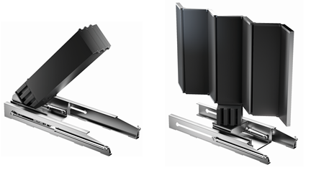

LED panels unfold silently within the next 45 seconds, presenting a screen of overwhelming brilliance on top of an elegantly dominating, almost sculptural masterpiece of technology to bring giant entertainment to fascinated viewers. The C SEED Supermarine´s unique qualities shine brightest when the Mediterranean or Caribbean sun is high: Its excep­tional luminosity of 4.500 nits and its contrast ratio of 4.500:1, together with a best pixel pitch and 48 bit color depth produce a crystal clear picture for state of the art out­door TV entertainment even in glaring daylight conditions.

**C SEED Supermarine Speakers**

From the moment C SEED Supermarine speakers majestically ascents, elegantly opening up to face the audience, you know the stage is set for an unforgettable performance. Visually, they complement the C SEED Supermarine TV monolith style. Acoustically, they are providing superior sound to round off perfect days, complement beautiful surroundings and entertain guests at superyacht parties.

The heart of the C SEED 125 was created by masters of outdoor speaker engineering L-Acoustic. Their passive speaker technology reproduces the entire frequency range with amazing and powerful brilliance. Built into one-piece metal casings, precision-machined out of massive blocks of aluminium, with sensitive parts made of stainless steel to ensure a long lasting lifetime, gives C SEED Supermarine speakers an ultimate resonating body for a sound that will overwhelm your senses.

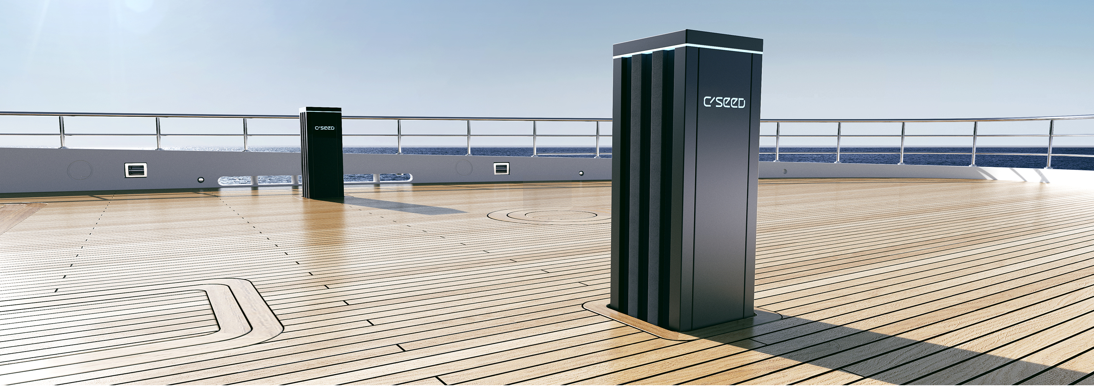

The new C SEED Supermarine TV and Speakers are available around the world.

**FOR MORE INFORMATION VISIT:** [www.cseed.tv](http://www.cseed.tv)

or inquire personally with:

Lea Sepac Basic

C SEED Entertainment Systems

Gußhausstraße 21/25, 1040 Vienna   
 Austria

T +43 676 7047999

Email: [lsb@cseed.tv](mailto:lsb@cseed.tv?subject=lsb@cseed.tv)

About us: C SEED Entertainment Systems matches minimalistic design with impeccable craftsmanship to create leading-edge luxury electronics. This award-winning company was founded in 2009 by Alexander Swatek together with Jakob Odgaard and Jorn Sterup, two former Bang & Olufsen managers. It is headquartered in Vienna, Austria, with a branch office in Los Angeles, California.